ITA0305- Mobile Computing
LAB EXPERIMENT
Name: G.Ganesh
Reg NO:192373008

4) Create a visual representation in Figma highlighting the key elements of mobile
network protocol stacks.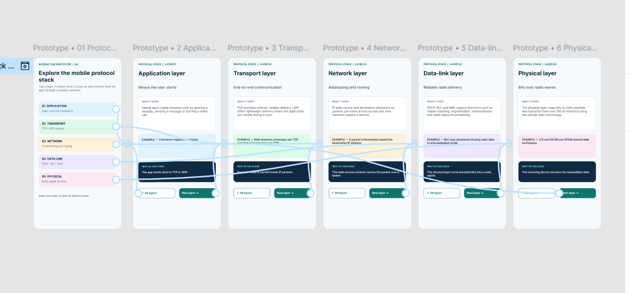
https://www.figma.com/design/D9TvZzr4T4H7NgtpZk8dWQ/program04?node-id=0-1&p=f&t=yGJeFeXBrRs1MaK7-0

